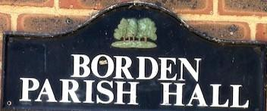
BORDEN PARISH HALL REPORT APRIL 2023

1. The ladies' toilets have been cleared and the new floor has been laid. Painting is now taking place.

2. As a result of the new lights needed in the ladies' toilets the old 3 phase fuse box cannot be used as the circuit breaker switch units are no longer available. A new fuse box is to be added under the main board which will give a safe connection for the new lights plus new outlets for the future.

John Hepburn

Chairman Borden Parish Hall

